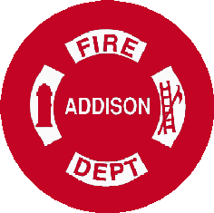
Addison Fire Protection District

Foreign Fire Insurance Board Agenda
August 21, 2019 (08:30)

Call to order
- Approval of Minutes
- Treasurer’s Report
  - Approval of Accounts Payable
- Correspondence
- Old Business
a. New Recliner for the Stations Update
- New Business.
  - HAAS Alerting System for Emergency Vehicles
  - Split Cost on Auto Vent 3000
  - Repair/Update the Coax Lines/Equipment Supplying the Living Quarters Cable
- Other Business at the Discretion of the Chairman
- Audience Participation
- Adjournment
The next meeting December 18, 2019

